CREATE DATABASE IF NOT EXISTS BANK;
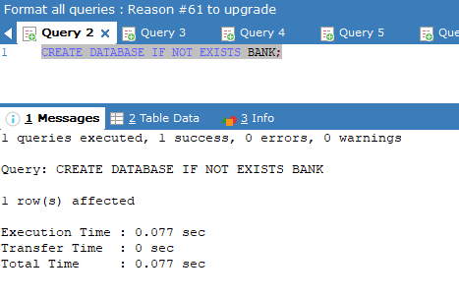
SHOW DATABASES;
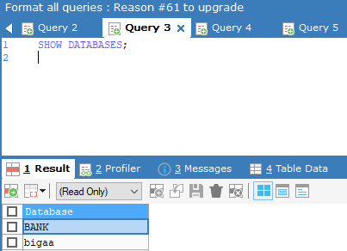

USE BANK;
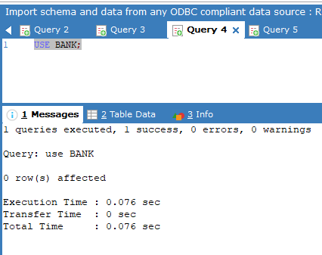

CREATE TABLE accounts (id INT8 PRIMARY KEY, balance DECIMAL);
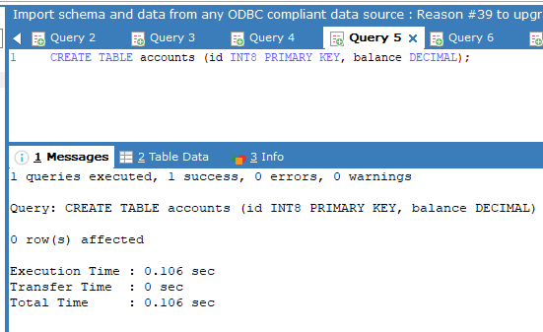
SHOW COLUMNS FROM accounts;
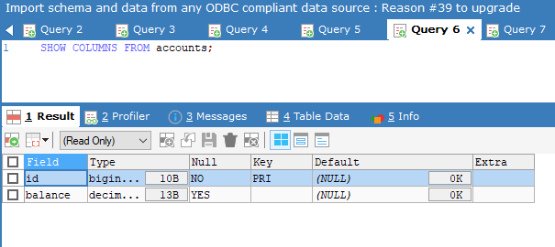

SHOW TABLES;
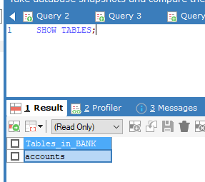

INSERT INTO accounts VALUES (1, 500.222)
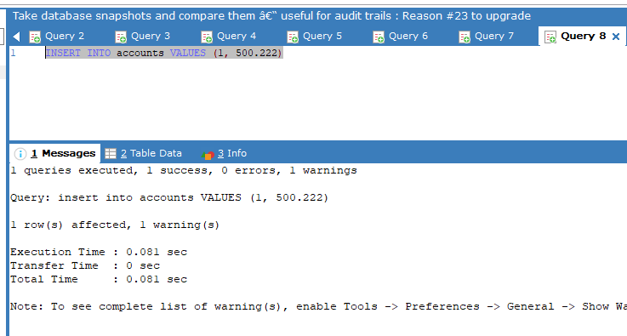
INSERT INTO accounts VALUES (2, 524242.11), (3, 8882882)
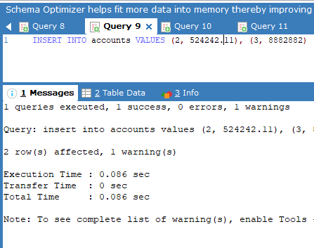
INSERT INTO accounts (balance, id) VALUES (33333, 4)
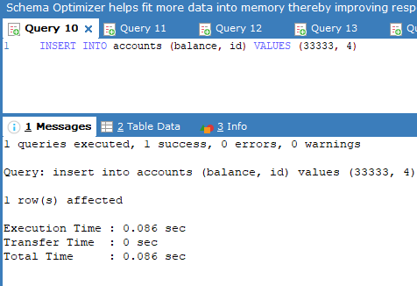
SELECT * FROM accounts WHERE id IN (5, 6);
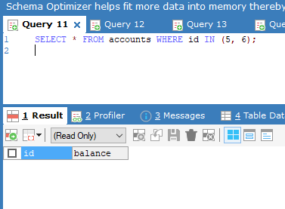
CREATE INDEX balance_idx ON accounts (balance DESC);
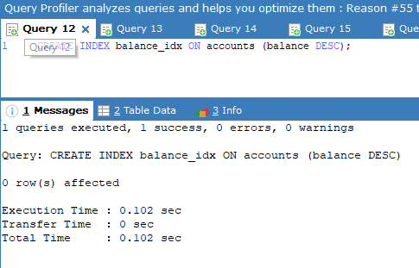
SHOW INDEX FROM accounts;
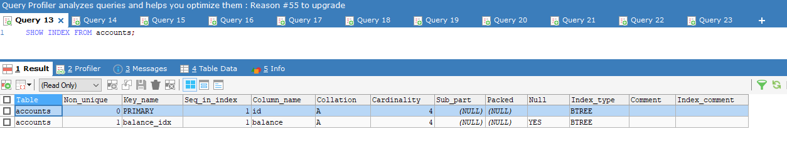

SELECT balance FROM accounts;
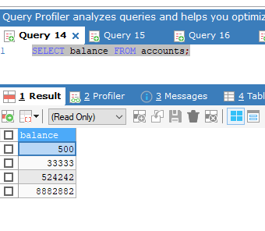
SELECT * FROM accounts;
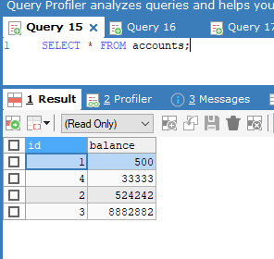
SELECT id, balance FROM accounts WHERE balance > 9000;
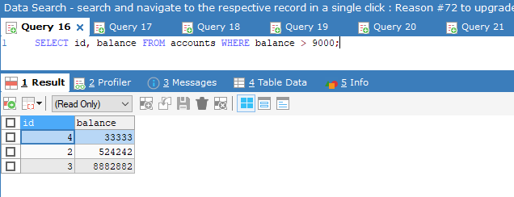
SELECT id, balance FROM accounts ORDER BY balance DESC;
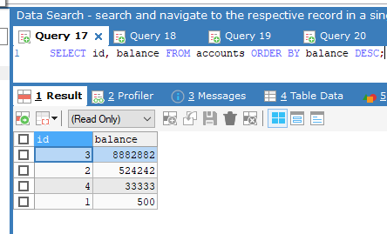
UPDATE
accounts
SET
balance = balance - 5.50
WHERE
balance < 10000;
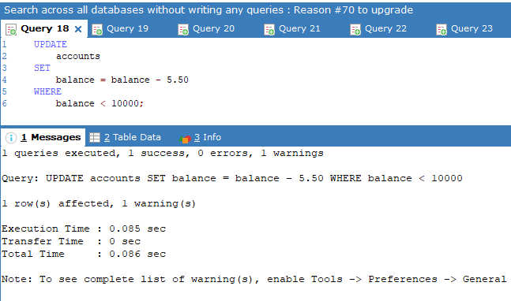

SELECT * FROM accounts;
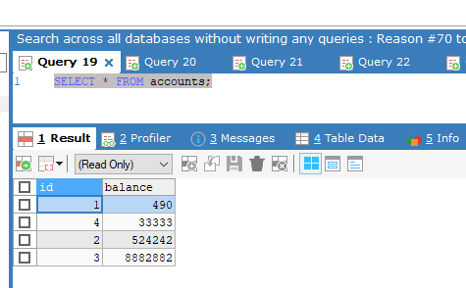

DELETE FROM accounts WHERE id in (5, 6);
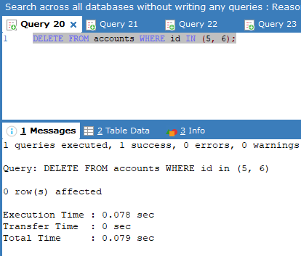
SELECT * FROM accounts;
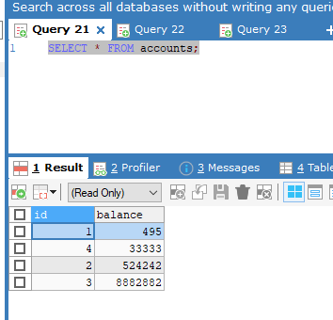

DROP TABLE accounts;
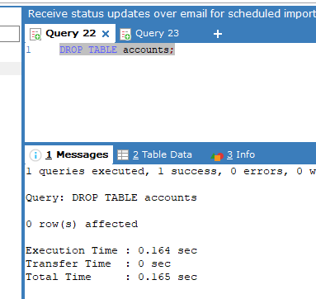

DROP DATABASE BANK;
